**Ideation Phase**

**Empathize & Discover**

|  |  |
| --- | --- |
| Date | 16 June 2025 |
| Team ID | LTVIP2025TMID56012 |
| Project Name | *OrderOnTheGo* |
| Maximum Marks | 4 Marks |

**Empathy Map Canvas:**

Understand the needs, frustrations, and behaviors of food delivery customers looking for a fast, reliable, and user-friendly way to order from nearby restaurants through a platform like *OrderOnTheGo*.

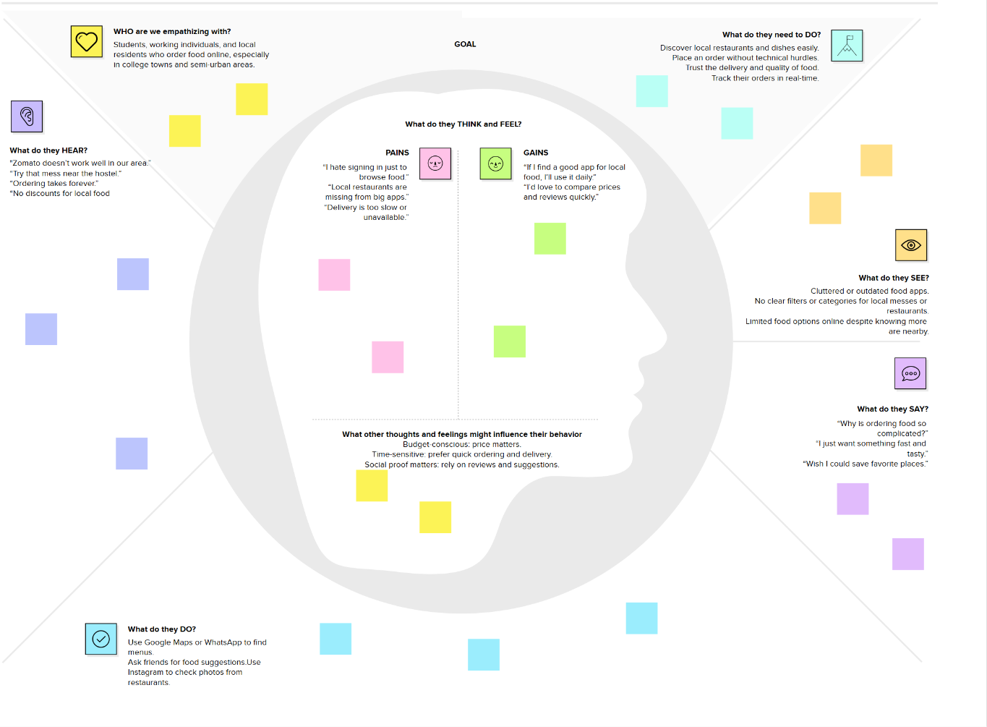

Link: https://drive.google.com/file/d/1yQEOG0dL-F2P0-dDkEkdlSZa-Z9WdqNI/view?usp=sharing

Reference: <https://www.mural.co/templates/empathy-map-canvas>